**Similar Applications and features selection**



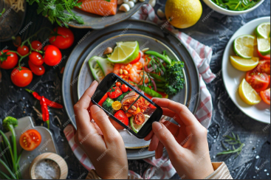

# **AI Photo Recipe identifier**

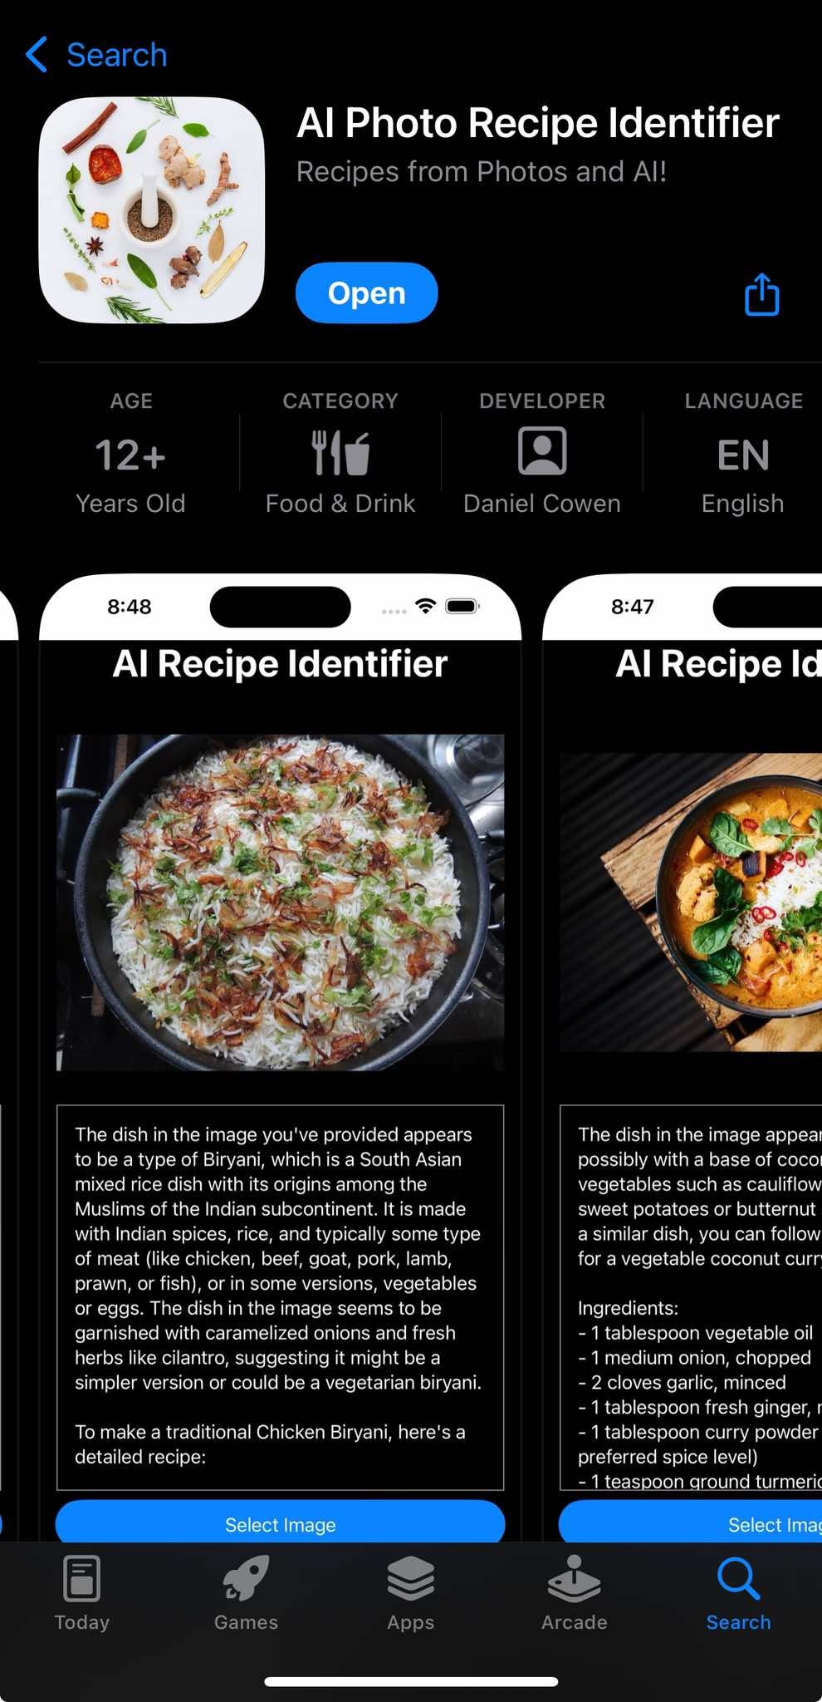The **AI Photo Recipe Identifier** app is designed to identify recipes from photos using advanced AI technology. Images of dishes or ingredients are analyzed, and corresponding recipes are provided. Custom recipes can also be generated based on detected ingredients, making it a valuable tool for culinary exploration.

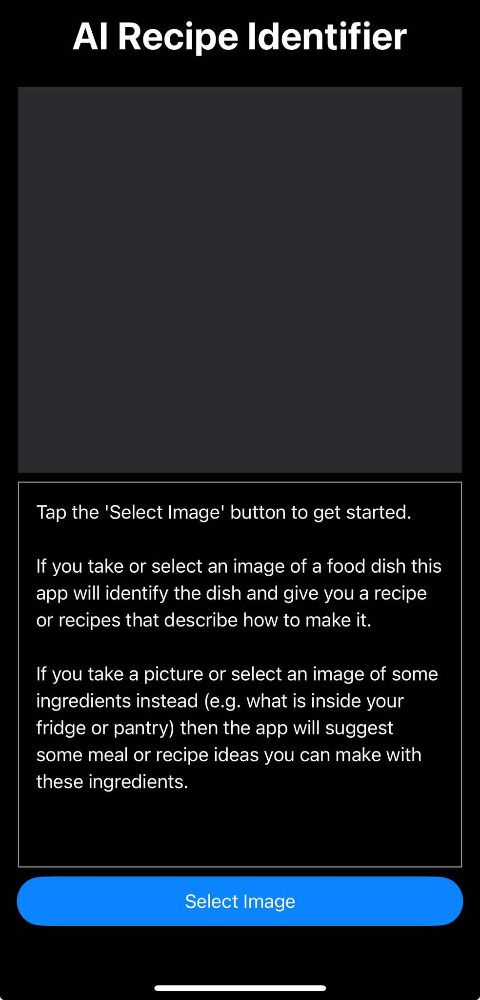First thing this application do is asking the user to select an image by taking a photo or uploading one, so the first two features are “take photo” and “upload photo” as shown below

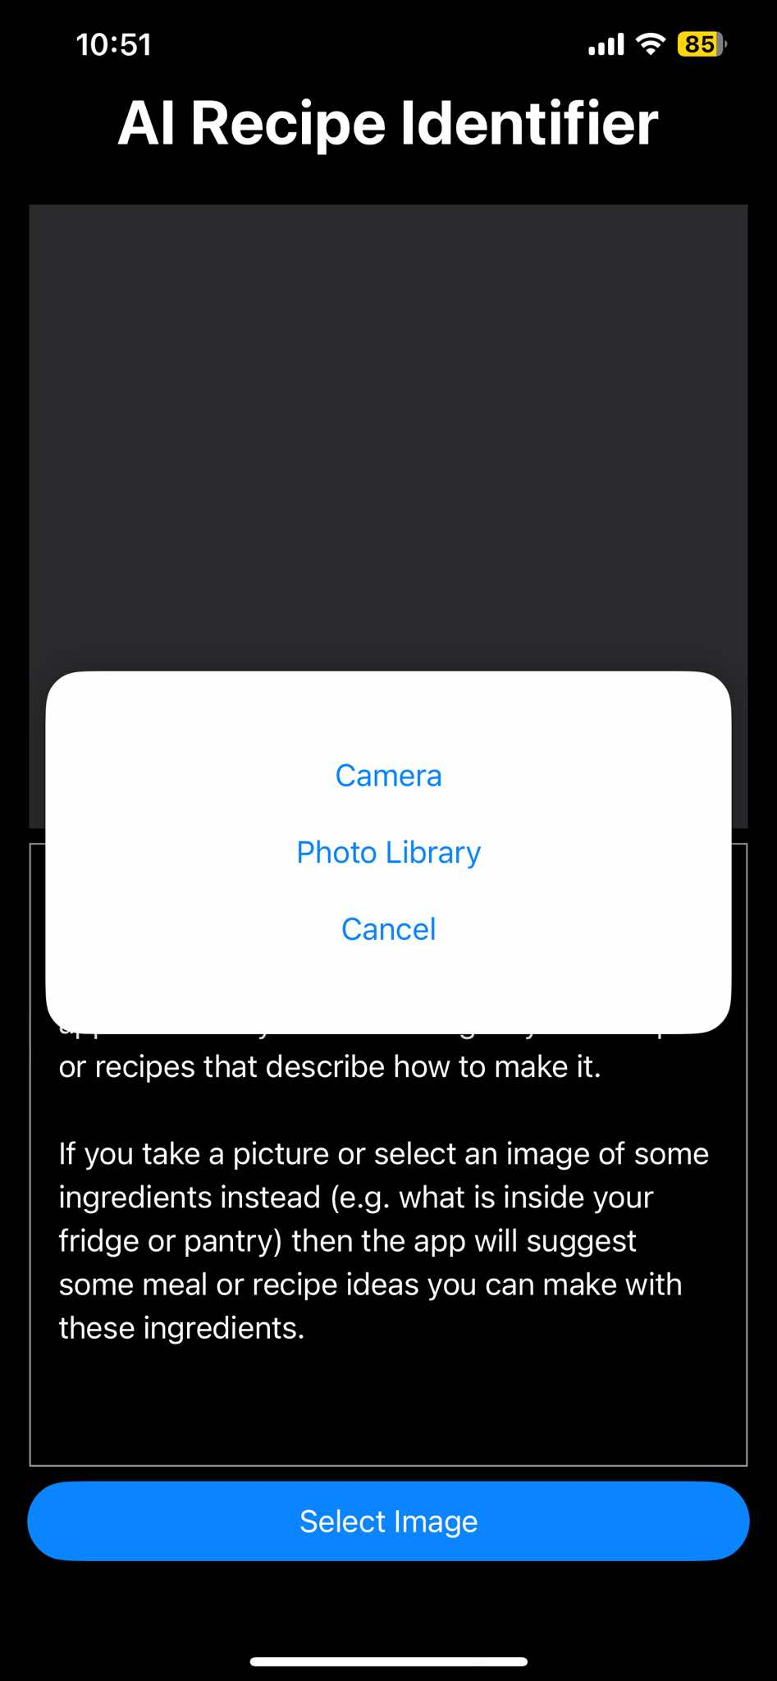

If “take photo” feature is chosen, the application provides the feature “Retake” which allows the user to retake the photo before using it to have its recipe, which is useful to have a good photo for the analyzing process, and if the photo is good the user press on use photo to use it.



Whether the user chose to take a photo or upload one, after that the application will give some information for that meal

* The name of that meal or ingredients in the photo and a short description for it.
* The ingredients for that meal
* The instructions (recipe) for that meal, if the photo has ingredients not a meal, the application will recommend custom recipes for these ingredients

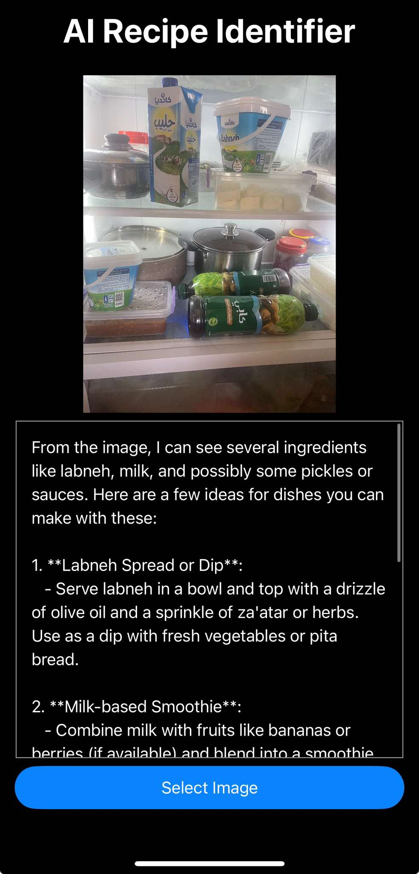The pictures below show the application results for an upload image of some ingredients in a fridge

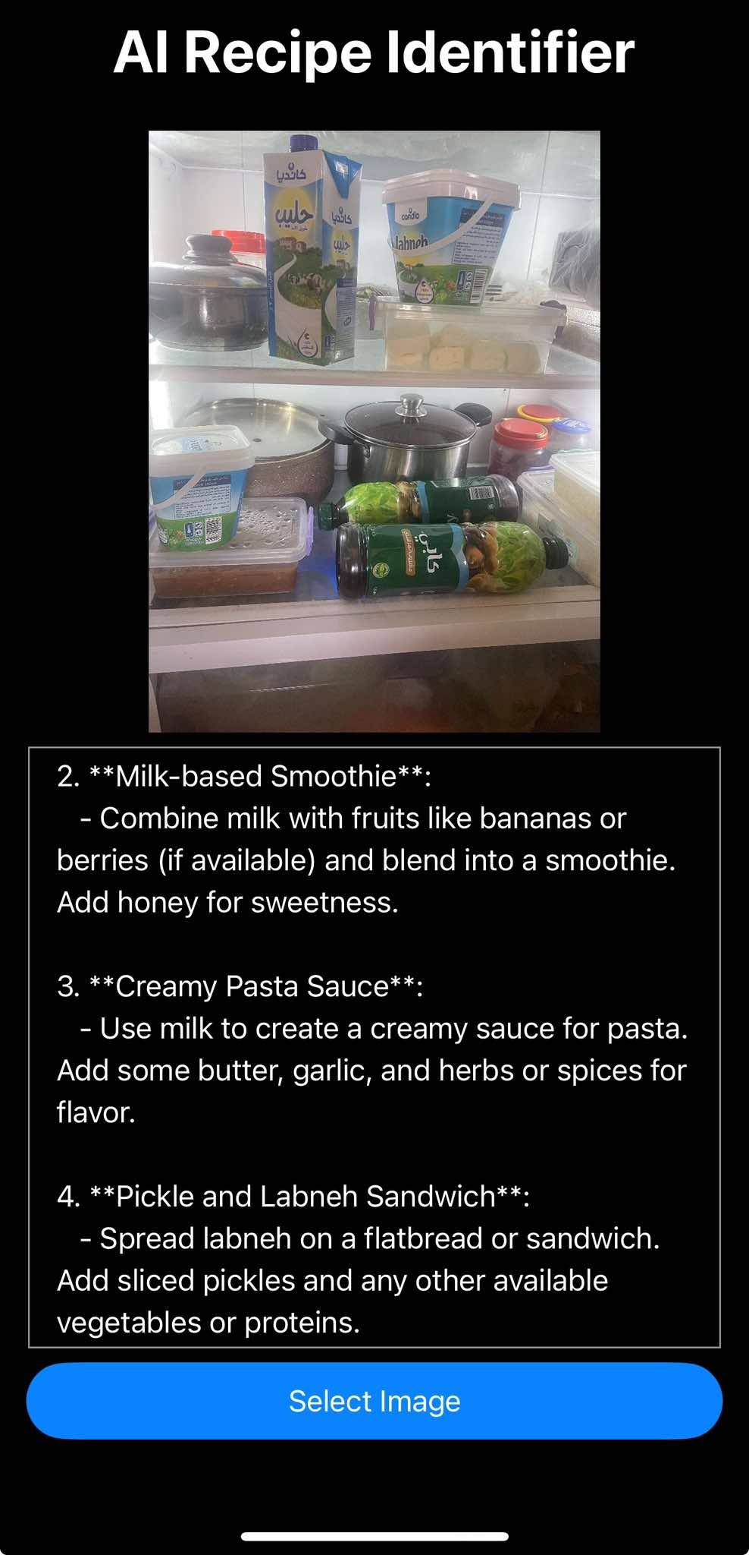

The below pictures show the application result for a Palestinian traditional meal ‘Maqluba’

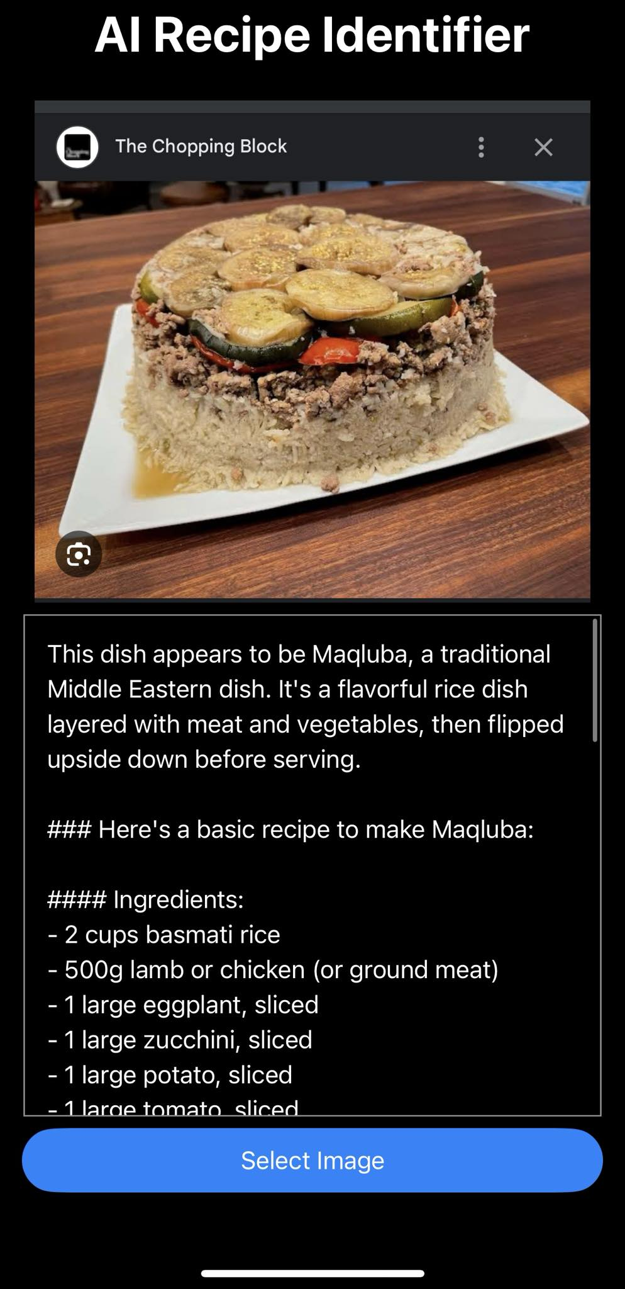

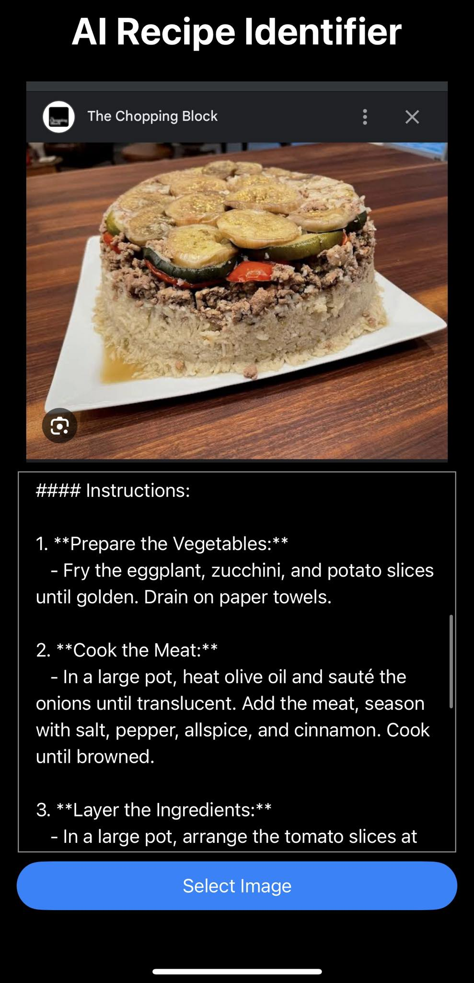

There is also a very similar application to Recipe identifier, called “AI get recipe by photo”, the picture below is its result to a canned slice of a pineapple

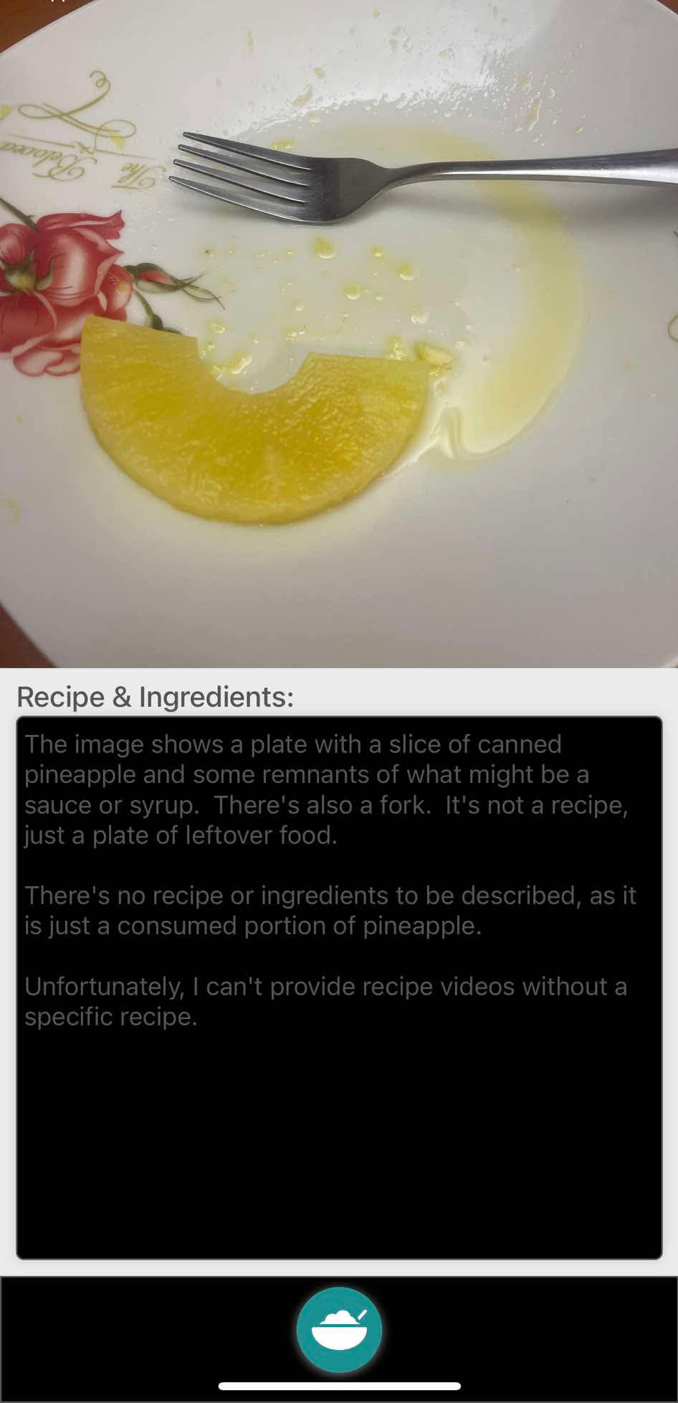

# **ChefMate AI**

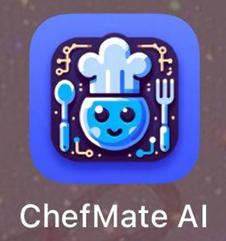

This app begins by scanning a meal to identify its ingredients. It then processes these ingredients to generate a variety of dishes that can be made with the same components. Users can select the correct dish from the options provided, and the app will generate the corresponding recipe for that selection.

 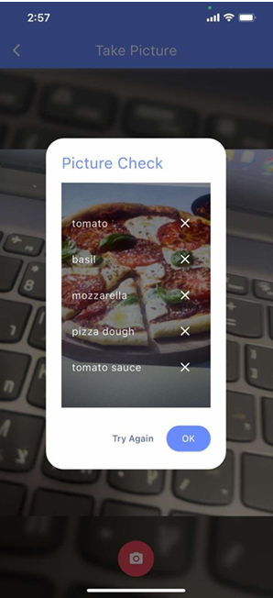 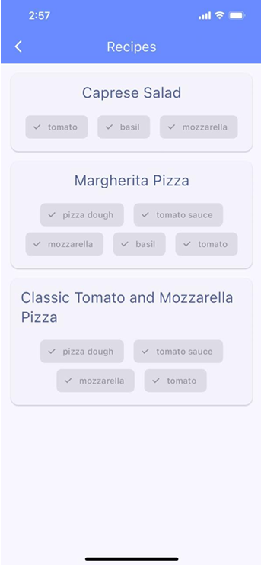

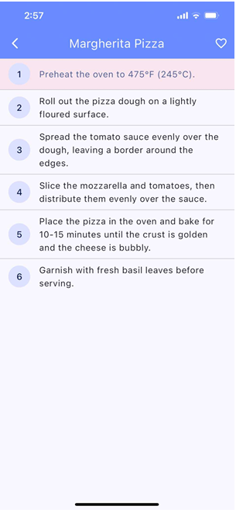

Features:

* Camera Scan
* retake picture
* picture check
* generated recipes
* recipes description
* add to favorites

# **ingreGenius**



This app starts with users signing in or creating an account. Afterward, they can scan a meal to identify its ingredients and simply click "Identify Meal." The app then generates a comprehensive report that includes the meal name, a brief description, calorie count, cooking time, nutritional data, ingredients, and a detailed recipe. Users also have the option to save their favorite meals for easy access later.

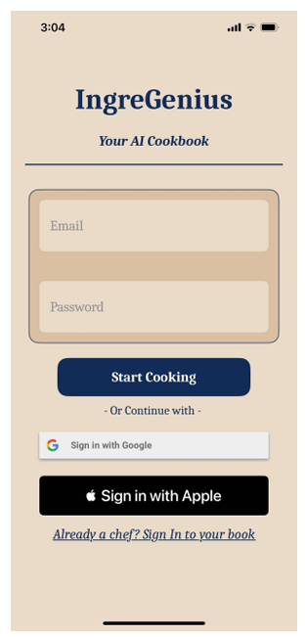

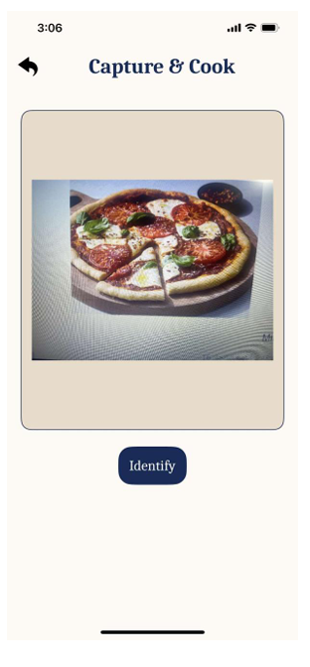

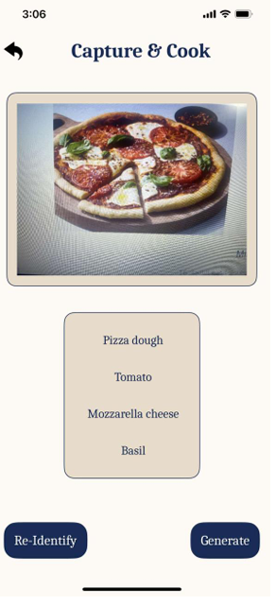

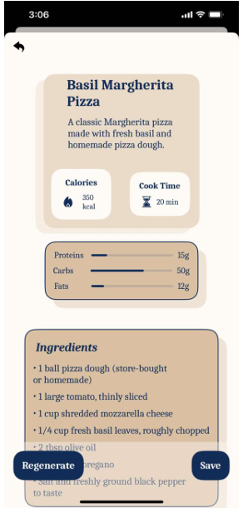

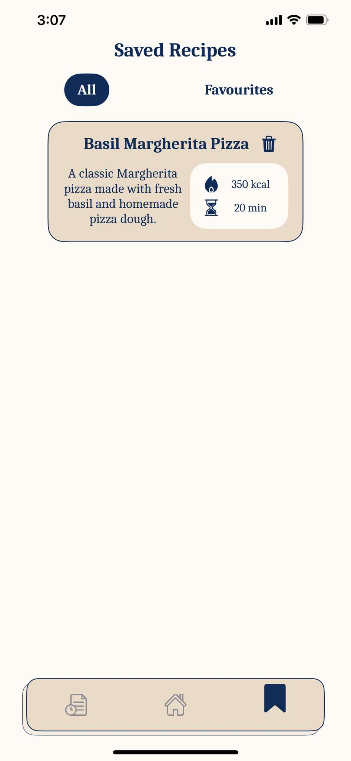

Features:

* Camera Scan
* generated recipes
* cooking time
* calories
* detailed ingredients
* recipes description
* save recipes
* add to favorites

# **SideChef**



**SideChef** is a cooking assistant app designed to simplify meal preparation by providing step-by-step recipes, interactive cooking guidance, and personalized meal planning. It uses AI and user-friendly features to help users cook with confidence, even if they are beginners in the kitchen.

**Key Features:**

1. Step-by-Step Recipes
2. Ingredient-Based Recipe Search
3. Meal Planning
4. Voice Command Support
5. Dietary Preferences
6. Edit Recipes
7. Cooking Timers
8. Save Favorite Recipes
9. Community Features

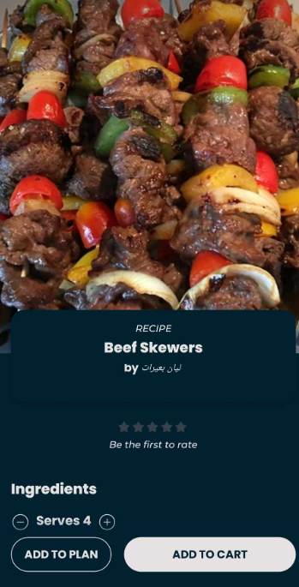

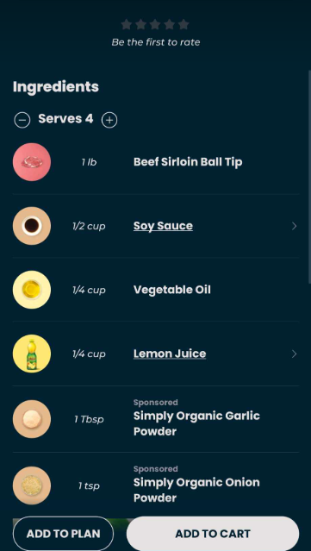

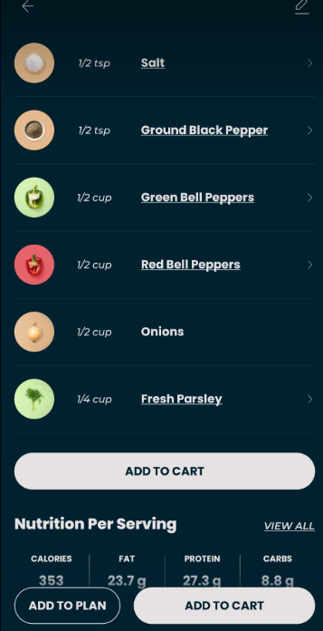

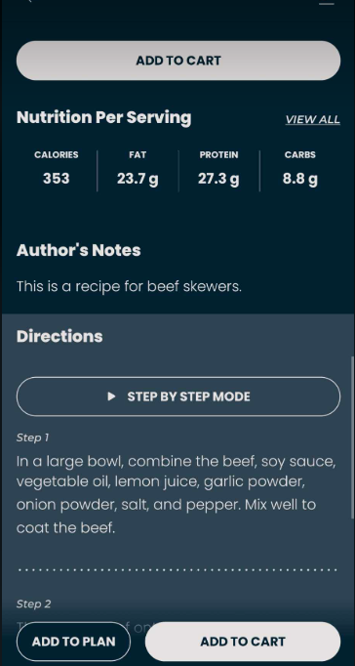

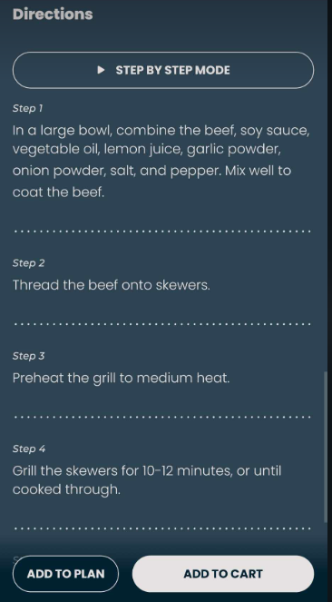

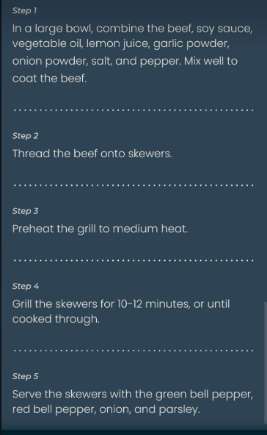

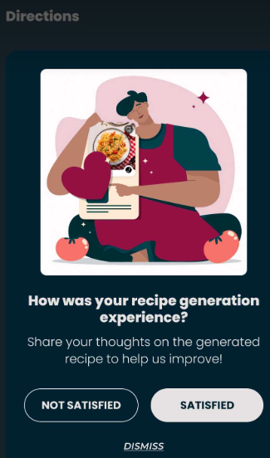



**Edit Recipe**

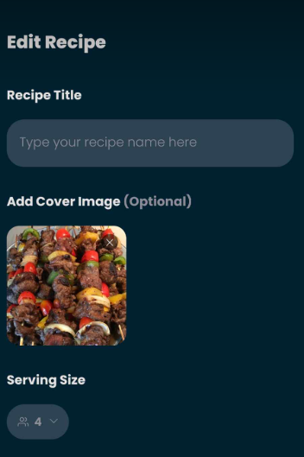

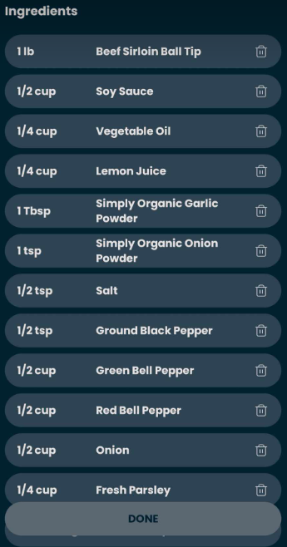

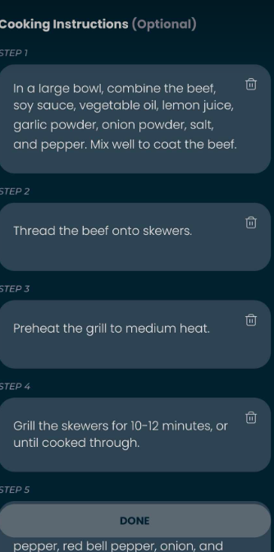

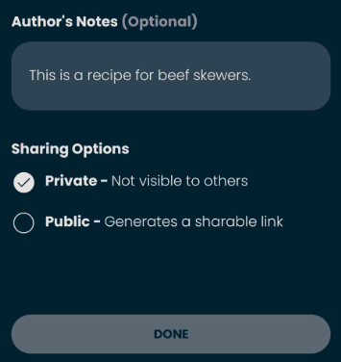



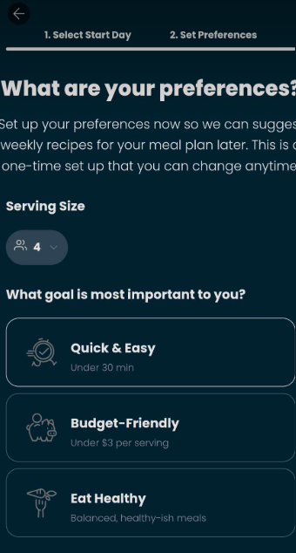

**Aim is most important**

**Size**

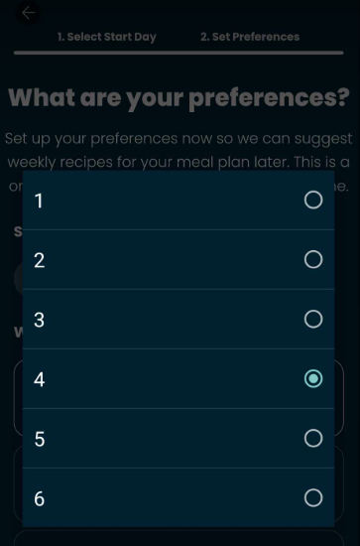

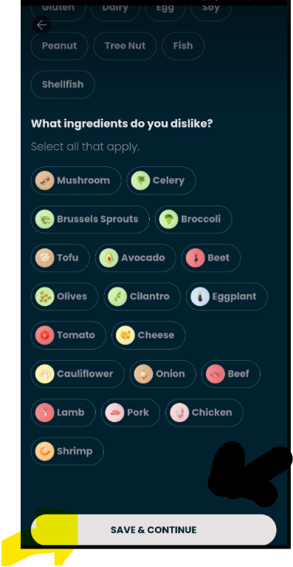

**Save**

**User Can Do:**

* Discover New Recipes
* Edit Recipes
* Plan Meals
* Save Time.
* Share Recipes

**What Use It Provides to the User:**

* Simplifies Cooking
* Saves Time
* Reduces Food Waste
* Encourages Healthy Eating
* Builds Confidence

# **FOODAI**



FoodAI is a smart calorie tracker and nutrition assistant that uses artificial intelligence to analyze food and provide detailed nutritional information. It helps users track their calorie intake, understand the nutritional content of their meals, and make healthier food choices.

**Key Features:**

1. **Food Scanning**
2. **Calorie Tracking**
3. **Nutritional Information**
4. **Meal History**
5. **AI Nutritionist**
6. **Dietary Preferences**
7. **Recipe Suggestions**

**What the User Can Do:**

* Track Calorie Intake
* Analyze Meals
* Receive Personalized Advice
* Discover Recipes
* Maintain Meal History

**What the App Does:**

* Food Analysis
* Calorie Calculation
* Nutritional Insights
* Personalized Recommendations
* Dietary Support

**What Use It Provides to the User:**

* Simplifies Calorie Tracking
* Promotes Healthy Eating
* Personalized Nutrition
* Encourages Variety
* Supports Dietary Goals

**Interface**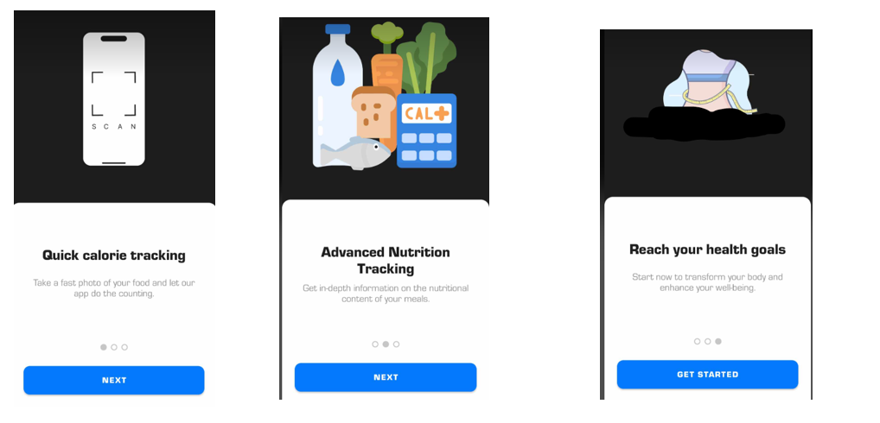

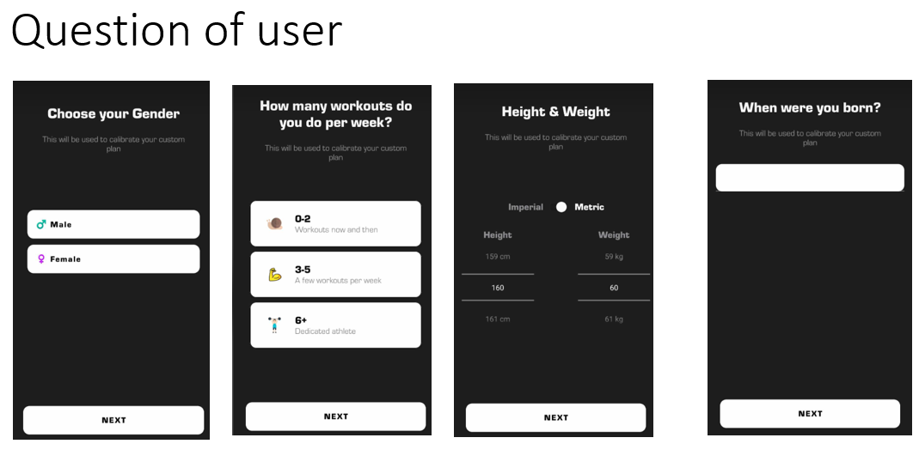

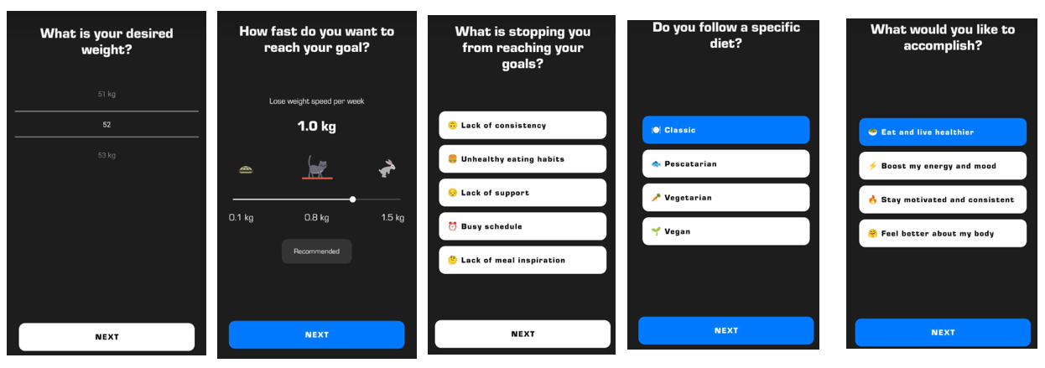

**Upload dataset of user’s & analysis**

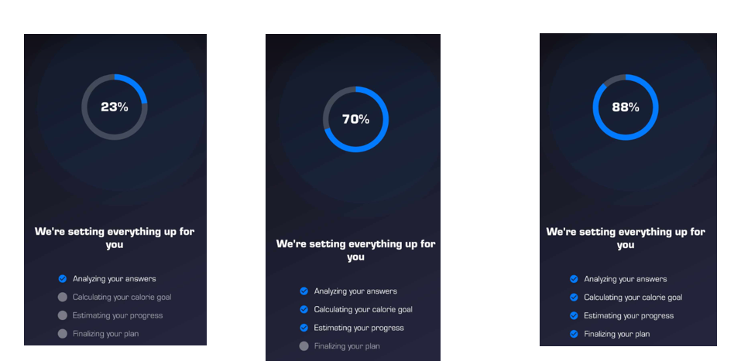

**Limit amount of each item bellow**

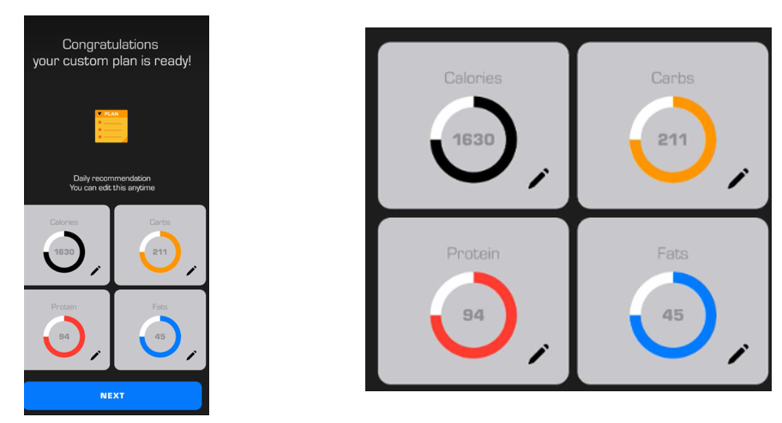

Now it open day & date of each week Daily summary take picture of today’s meal’s

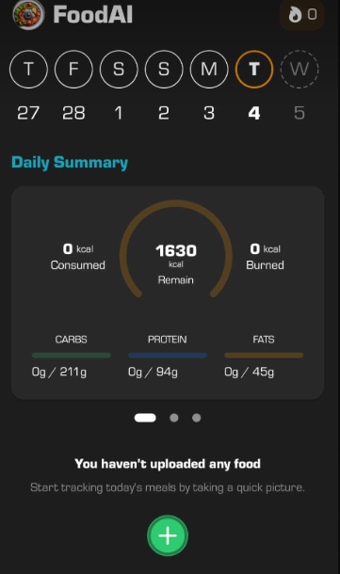



click of + button  
 scan food   
log exercise  
if click of scan food  
as shown

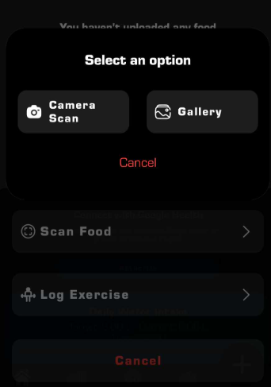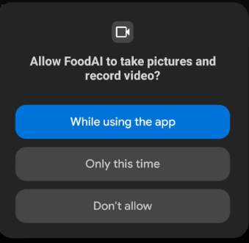



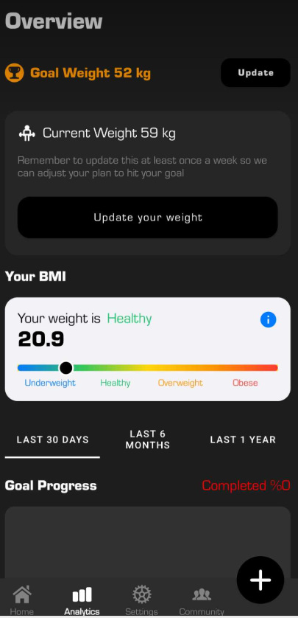

1. **Pic2Recipe**

**Pic2Recipe** is an innovative app (and web-based tool) developed by researchers at MIT's Computer Science and Artificial Intelligence Laboratory (CSAIL). It uses **Artificial Intelligence (AI)** and **computer vision technology** to analyze photos of food and identify the dish, its ingredients, and even suggest recipes.



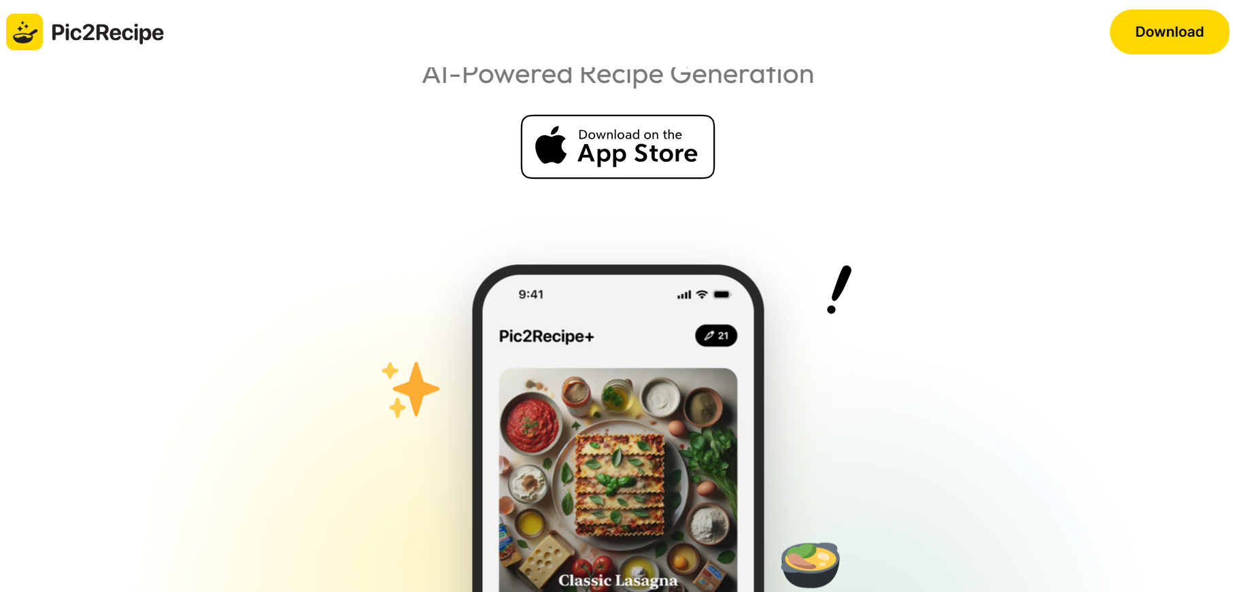

Link of web: [Recipe1M+: A Dataset for Learning Cross-Modal Embeddings for Cooking Recipes and Food Images - MIT](https://pic2recipe.csail.mit.edu/)

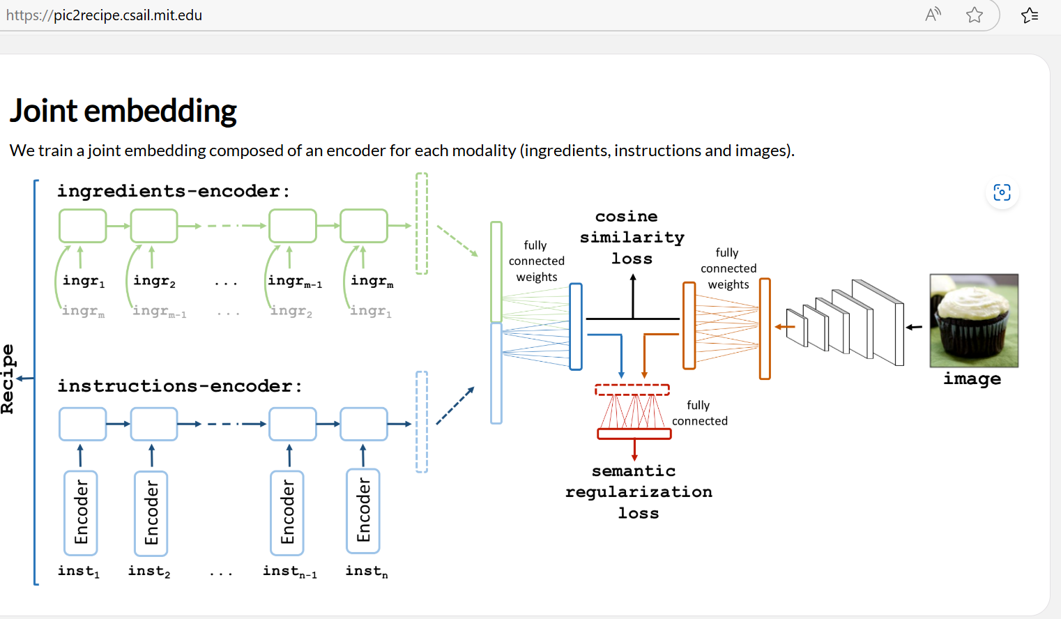

**What the User Does:**

1. **Take or Upload Photos:**
   * Users can take a photo of a dish using their smartphone or upload an existing photo from their gallery.
2. **Get Recipe Suggestions:**
   * The app analyzes the photo and identifies the dish, its ingredients, and suggests similar recipes.
3. **Explore Recipes:**
   * Users can browse through the suggested recipes, view cooking instructions, and save their favorites.
4. **Customize Recipes:**
   * Users can modify the suggested recipes based on their preferences or dietary restrictions.
5. **Learn About Ingredients:**
   * The app provides information about the ingredients used in the dish, including nutritional details.

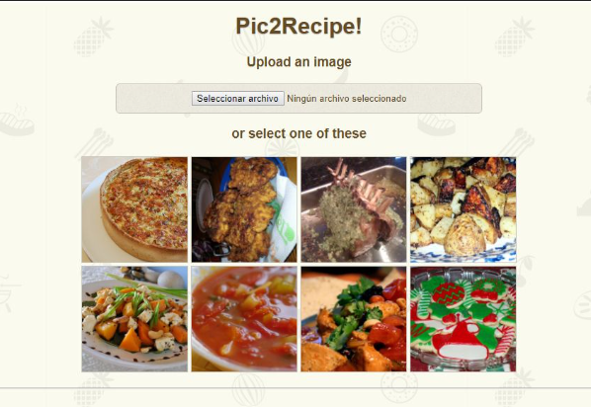

**What the App Does:**

1. AI-Powered Photo Analysis
2. Ingredient Recognition
3. Recipe Database:
   * The app connects to a large database of recipes to provide accurate and diverse suggestions.
4. Nutritional Information:
   * The app may provide nutritional details about the dish, such as calorie count, macronutrients, and allergens.

**Key Features:**

1. Photo Recognition
2. Recipe Suggestions
3. Ingredient Breakdown
4. Nutritional Information
5. Recipe Database
6. Cross-Platform Availability

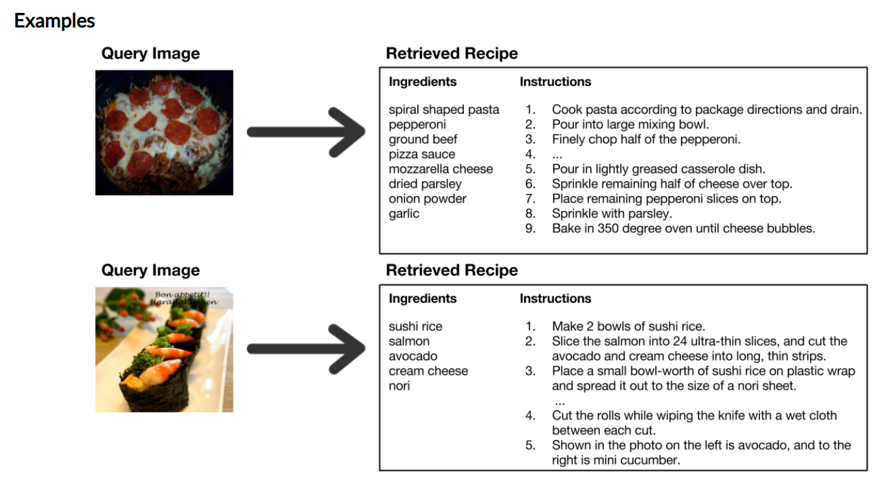

Link of web: [Recipe1M+: A Dataset for Learning Cross-Modal Embeddings for Cooking Recipes and Food Images - MIT](https://pic2recipe.csail.mit.edu/)

**Why It’s Useful:**

1.Quick Recipe Identification

Users can instantly identify dishes they see in restaurants, on social media, or at friends' homes.

2.Learn to Cook New Dishes:

3.Ingredient Insights:

Users can learn about the ingredients in a dish, which is helpful for dietary restrictions or allergies.

4.Save Time:

Instead of manually searching for recipes, users can get instant suggestions based on a photo.